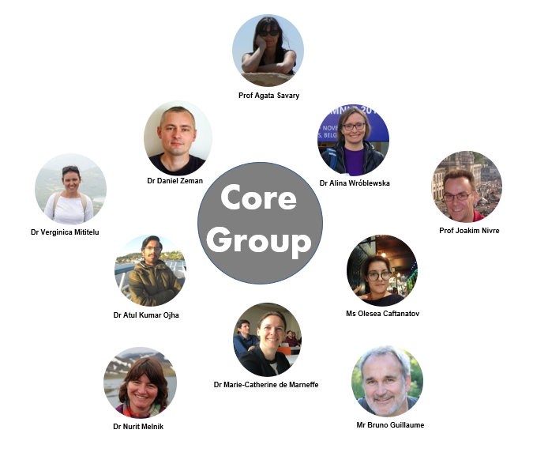
Following the UniDive MC vote on 23 Sept 2022:
- The UniDive leadship is in the hands of the Core Group (CG) consisting of 11 members: the Action's Chair, Vice-Chair, GH Scientific Representative, WG leaders, Grant Awarding Coordinator, Science Communication Coordinator, Grant Holder Manager, and YRI Representative.
- Additionally to day-to-day management of the Action, the following rights and powers of the MC are delegated the Core Group:
  - Approving/refusing WG applications
  - Selecting event participants who will be reimbursed
  - Adjusting the location and dates of activities (in close consultation with the Local Organizer)
The UniDive Extended Core Group includes, additionally to the Core Group members, also the WG co-leaders, the Science Communication Vice-Coordinator and the Grant Awarding Vice-Coordinator.
All names and contacts are to be found at the official COST page.
See also the list of past and upcoming (Extended) Core Group meetings.

