UniDive 1st general meeting - social events
- Back to the UniDive 1st general meeting page

Awakening of the birds
A few days before the World Sparrow Day (March 20th), we will observe and listen to birds in this morning walk near the University campus. How to observe them well? How to identify them by appearance and sound? What do their songs express? This walk in the middle of a forest ecosystem will bring us closer to passerines that are preparing to nest. We will also talk about birds that are gradually returning from their long migration.
Organisational details:
- Guided tour: with Solen Boivin and Caroline Widmer, nature guides from the Chevreuse Valley
- Date of the event: Friday, 17 March
- Starting at 6:30 a.m. at the entrance of the Paris-Saclay Campanile hotel
- Ending at 8:30 a.m. at the meeting venue, LPS (building 510)
- Capacity: 2 groups of up to 25 persons (registration no later than Friday 10 March is free but required)
- Breakfast will be offered to participants after the tour
- French spoken, with (amateur) English translation; your favorite speech translators are welcome
- Wear hiking shoes, bring umbrellas and binoculars, if you can
Here are some of the birds which we might hear or watch (credit: Olivier Lassalle, LISN & Cyprienne Savary):
Blue tit (credit: Olivier Lassalle, LISN) | 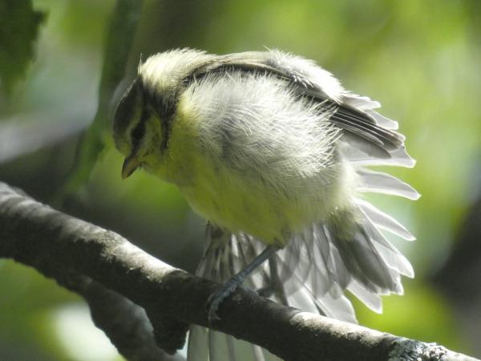 | woodpecker-at-work.mp4
Blue tit baby calling its parents | Blue tit (baby) | Woodpecker at work
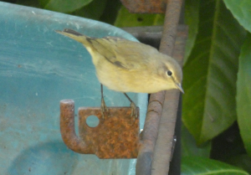 | 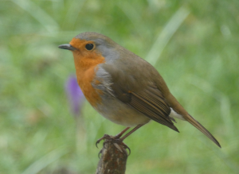 | 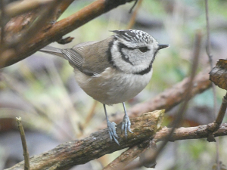
Chiffchaff | Robin | Crested tit

Hike on Saturday morning
- Starting point: the suburban train station (RER B) at Bures-sur-Yvette (direction: Saint Rémy lès Chevreuses). Meeting at 9:40 a.m.
- Duration: about 5-6 hours
- Hardness: easy; about 10 km; up to 300 m of slope in total
- Equipment: hiking shoes, your own picnic
- Highlights: Port-Royal-des-Champs (the spot of an ancient abbey and school which played important roles in the 17th history of France; strongly related to Jean Racine and Blaise Pascal inter alia), the picturesque valley of the Yvette river, a view from the Madeleine chateau on the valley

Concert on Saturday evening
Dances and masks from Bali - a performance at the Philharmonie de Paris, Saturday 18 March 2023 at 8 p.m. You are welcome to join Nurit and Agata (seats JJ2 and JJ4).
Here is a personal selection of other concerts on Saturday evening 18 March 2023 (credit: Benoît Goldschmidt):
- 30th anniversary of the Accentus choir - at the concert hall La Seine musicale (Mendelssohn)
- Tribute to Bach's "L'art de la fugue" - at Maison de la Radio (baroque and contemporary music)
- Elliott Murphy - at the New Morning concert hall (American rock and folk)
- Stravinsky, Le Rossignol / Poulenc, Les Mamelles de Tirésias - by French soloists and Les Siècles ensemble, on historical instruments, Théâtre des Champs-Elysées (classical music)
- Matthew Blackburn - Beethoven, Ravel, Brahms, Tchaikovsky, Fauré; at L’Accord Parfait studio (piano)

Visiting Paris
If this is your first time in Paris, you will probably want to visit the highlights and tons of websites will help you make your choice. The most popular museums (Louvre, Musée d'Orsay, etc.) are always crowded, take time to buy tickets online in advance.
Other places I personally like and recommend are:
- Musée de Cluny - a museum of the Middle Ages, in the very heart of Quartier Latin, with the series of tapestries “The Lady and the Unicorn”.
- Richelieu Library - the old building of the French National Library, recently restored and open to public, with the amazing Oval Reading Hall and a museum with rich collections.
- Cité Internationale Universitaire de Paris - a huge area of student houses, founded in 1920-ies, with many nationalities represented by architectural design. Some famous architects contributed their projects, e.g. Le Corbusier.
If you know Paris already, you might enjoy temporary exhibitions which happen to overlap with the UniDive meeting. Here is a personal selection (credit: Benoît Goldschmidt):
- Hiroshige and the fan, a travel to the 19th century Japan - at Guimet Museum; a collection of folding fan printmaking masterpieces by Utagawa Hiroshige (1797-1858).
- Alberto Giacometti / Salvador Dali. Gardens of Dreams - an exhibition at the Giacometti Fondation about the creation of an imaginary garden in the early 1930-ies.
- Crowds (fr. /Foules/) - an exhibition at the Science and Industry Museum about phenomena related to the behaviour of crowds (fluid mechanics, granular physics, mathematics, cognitive science, social psychology, etc.)
- On the roads to Samarkand. Wonders of silk and gold - a collection of unique mastrepieces exhibited for the first time outside of Uzbekistan, at the Institute of the Arab World.
- Henri Cartier Bresson Center - two temporary exhibitions, dedicated to the American photographer Paul Strand (1890-1976) and to a photo dialogue between Helen Levitt (1913-2009) and Henri Cartier-Bresson (1908-2004).
- La Fabuloserie - 40th anniversary exhibition of the Saint Pierre's Hall, dedicated to outsider art (art brut).
- Matisse. Cahiers d’art, the pivotal 1930's - some masterpieces of Matisse from the 1930-ies, rarely shown.
- Fabrice Hyber "The Valley" - a monograph exhibition at the Cartier Fondation.
- Zanele Muholi - an exihibition dedicated to a South-African photographer and activist, documenting black LGBTQIA+ communities.

