1st UniDive training school
- Event title: 1st UniDive training school
- Location: Chișinău, Moldova (relocated from Jerusalem, Israel)
- Date: 8-12 July 2024
- Location: Technical University of Moldova
- Local Organizers: Victoria Bobicev & Olesea Caftanatov
 |  | 
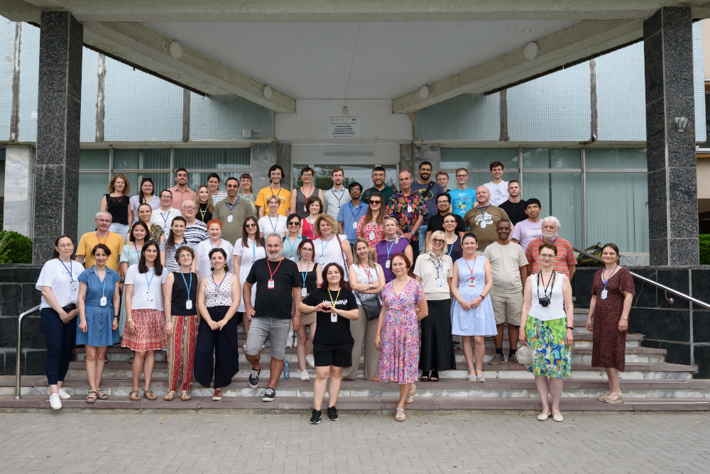
More photos

Courses and training material
See below for the recordings of the lectures.
- Course 1: Dependency syntax, Surface-Syntactic UD and UD - by Sylvain Kahane
  - Lecture 1.1 and 3.2: Basics of treebank querying and annotation
  - Lecture 1.2: Dependency syntax, Introduction and History
  - Lecture 1.3: Dependency syntax, Syntax Principles
    - Exercises
- Course 2: Annotation of multiword expressions for newcomers - by Verginica Mititelu and Voula Giouli
  - Lecture 2.1: Definition, characteristics, MWEs in NLP tasks, PARSEME shared tasks and the importance of corpora
  - Lecture 2.2: Decision trees
  - Lecture 2.3:
    - FLAT User's guide and annotation
    - Generic decision tree
    - VMWE Annotation Guidelines v1.3
    - NMWEs-decision tree
    - ModMWEs-decision tree
  - Lecture 2.4: Annotation and issues
- Course 3: Corpus annotation infrastructure - by Bruno Guillaume, Daniel Zeman and Agata Savary
  - Lecture 3.1: Git infrastructure
  - Lecture 3.2 and 1.1: Basics of treebank querrying and annotation
  - Lecture 3.3: Corpus format validation
  - Lecture 3.4: Advanced treebank querying and annotation
  - Lecture 3.5:
    - Slides Dan
    - Udapi tutorial
    - Error mining (slides Bruno)
  - Lecture 3.6: Documentation and discussion on Git
- Students' sessions
  - Students' presentations of challenging syntactic phenomena and MWE examples
  - Brainstormin Hackaton
    - Brainstorming room to submit issues for discussion and vote for them
    - Slides for issue 1: [Chiara] At what point of the creation of a corpus should multiword expressions annotation be implemented? What would be more advisable? Starting right away or annotating them later?
    - Slides for issue 2: [Enriketa] What strategies can be employed to improve the annotation of the verb “to be” and its classification as auxiliary or main verb?
    - Slides for issue 3: [Arianna] How to annotate ungrammatical input such as “I am having some *difficult.” (ADJ instead of NOUN and similar)?
    - Slides for issue 4: [Claudia] I would suggest the possibility of introducing dependency relation subtypes for ellipsis. That could facilitate the rapid extraction of ellipsis sites and their contexts in treebanks that do not present an enhanced dependency annotation.
    - Slides for issue 5: [Anila, Adelina, Nelda] Is it feasible to incorporate semantic information—specifically, the meaning of a multiword expression (MWE)—in addition to its tag (e.g., Vid, Nid)?
    - Slides for issue 6: [Abnet] How to choose between two relations (obl and advmod) for derived words that serve as adverbs (almost lexicalized)?

Latest news
The following input is available:
- List of Gitlab and Github account for of the trainees
- A shared document for questions and issues from the trainees
Prerequisites for the courses:
- instructions about how to prepare the prerequisites for the courses
- Github repository (it will be gradually updated with the training material)
Sightseeing:
- Folk & Art Souvenirs Shop
- Top tourist attractions of Chișinău
Instructions:
- instructions for personal introductions
- instructions for poster presenters
Call for participating and results:
- List of accepted trainees' projects and posters
- Call for participating in first edition of UniDive Training School Call for applications

Schedule
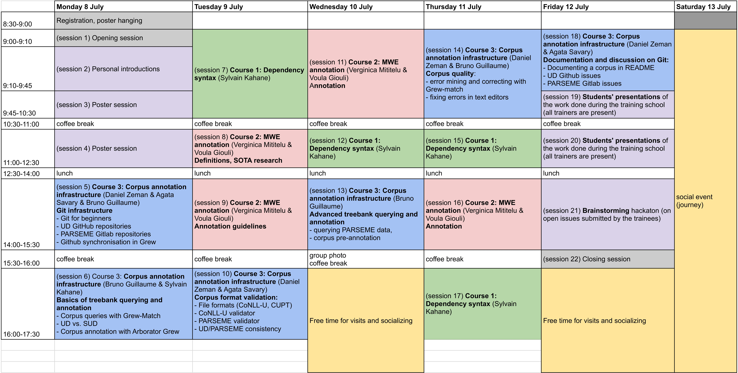

Recordings
Here, you can access the video lessons from the Unidive Training School. The videos are organized by days and sessions. If the link stops working in the future, please write a message to this email: olesea.caftanatov@math.md. Enjoy watching them!
Day_1
- Session 1 and 2
- Session 5 Course 3 Corpus Annotation Infrastructure
- Session 6 Course 3 Basics Of Treebanks
Day_2
- Session 7 Course 1 Dependency Syntax
- Session 8 Course 2 MWE Annotation
- Session 9 Course 2 MWE Annotation
- Session 10 Course 3 Corpus Annotation Infrastructure
Day_3
- Session 11 Course 2 MWE Annotation for Newcomers (Video Recorder)
- Session 11 Course 2 Annotation of Multiword Expressions for Newcomers **BigBlueButtom Recorder**
- Session 12 Course 1 Dependency Syntax
- Session 13 Course 3 Corpus Annotation Infrastructure
Day_4
- Session 14 Course 3 Corpus Annotation Infrastructure
- Session 15 Course 1 Dependency Syntax
Day_5
- Session 18 Course 3 Corpus Annotation Infrastructure
- Session 19-21 Students' presentation
PS.Some video lessons may take a little more time to be uploaded.

Location and directions
Location: The tutorials, practical sessions and other school activities will take place at the Computers, Informatics and Microelectronics Faculty, Technical University of Moldova, see faculty building on the map.

Local information
- Please, be aware that Moldova is not in European Union yet.
- Local currency in Moldova is Moldovan leu, it costs roughly 5 euro cents rate. You can change some cash in the airport; in some cases, you have to pay cash, for example in local transport.
- Your European mobile cards will be in roaming in Moldova, be careful to check how much it will cost you to call or use mobile internet. Fortunately, you can often catch wifi in the airport, at the University, in café, etc.
- Moldova follows Eastern European Summer Time, 3 hours ahead from the UTC universal time.

Directions
- There is only one airport in Moldova: Chisinau airport. Plenty of air companies are flying to Chisinau: Austrian Airlines, Lufthansa, Turkish companies, WizzAir, LOT Polish airlines, Eurowings, HiSky, FlyUp and some others. We have to warn you to be cautious with FlyOne company, it often change or cancel their flights.
- You can use taxi from the airport although the taxi drivers that are waiting there and catching arriving people ask for much higher price than if you call a taxi using an app. If you want to save some money, you can use the trolleybus number 30 that stops right in front of airport building and will take you straight to the city center. The only problem with this trolleybus that it goes every half an hour; so you have to wait.
- In the city buses and trolleybuses you pay directly in the transport, it costs 6 lei, around 30 cents. You can use Google maps or EasyWay app to navigate using local transport.
- Taxi is comparatively cheap; you can use hip taxi to call a taxi for example although there are other taxi apps like Letz or Yandex Go.

Accomodation
There are many hotels in the Chisinau city; you can use booking.com, travel.md or hotels.md to book one. Unfortunately, there are not hotels close to the school venue. The closest one we recommend is Insitutul Muncii Hotel. Other hotels are:
- Shadow Hotel;
- City Park Hotel;
Also there are many possibilities to rent an apartment close to the school venue, for example:
- Apartment OneClickRenrt Oasis Booking link
- Flatkeepers - city view Booking link
- Apartment Deluxe on Moscow Avenue, Booking link
- Retreat Studio Booking link
The cheapest accommodation is in the university dormitories next to the faculty building but most of them has been offered to the refugees from Ukraine and they are still living there. If you intend to book the room in the dormitory write directly to organizers (victoria.bobicev@ia.utm.md) but be aware that the price is really low (5 euro/day) but the conditions are frugal.

