UniDive 2nd WG3 meeting in Istanbul
- Event title: UniDive 2nd Working Group 3 meeting
- Location: Electric and Electronics Faculty Idrıs Yamanturk Conference Hall - Istanbul Technical University, Turkey
- Dates: 8 September 2023
- Local Organizer: Gülşen Eryiğit
 |  | 
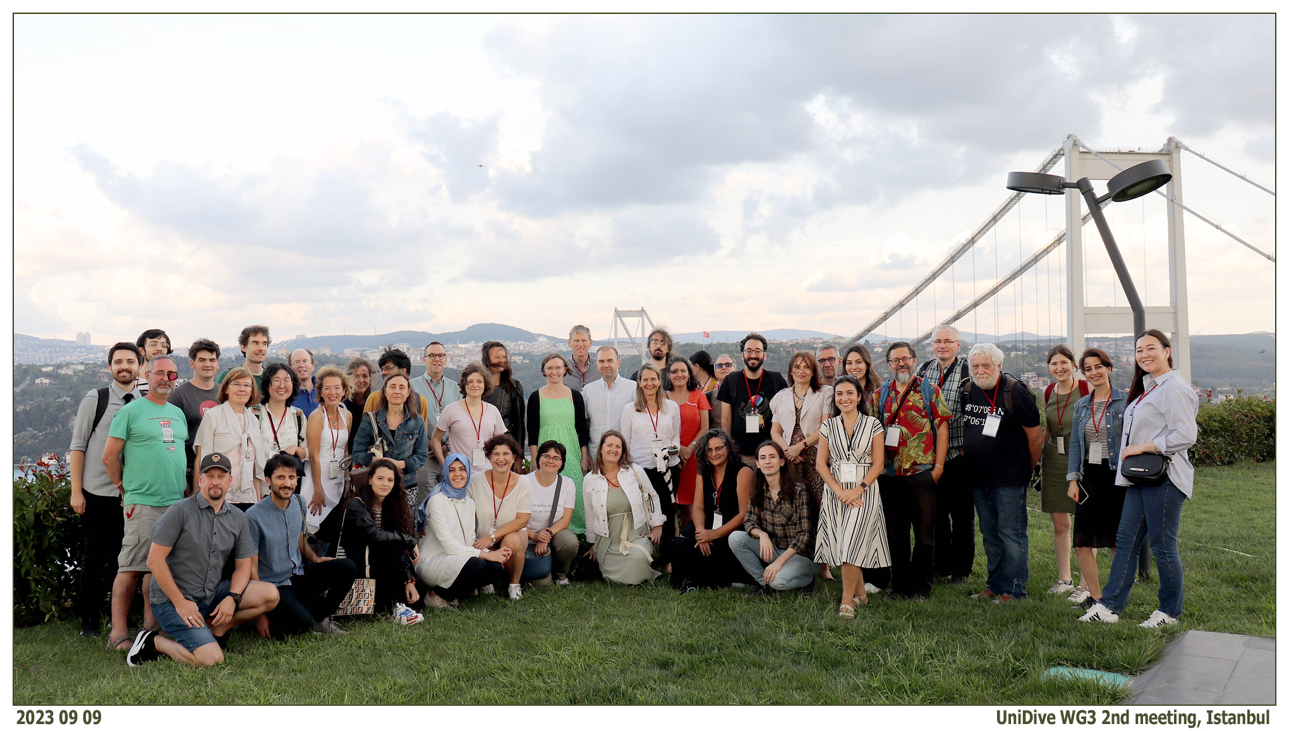

Purpose and Organisation of the Meeting
This meeting is dedicated to UniDive WG3 and will focus on the coordination and documentation of multilingual (including cross-lingual) language technology tools of relevance to UniDive. More specifically, we will try to make progress on the two initial subtasks identified at the WG3 meeting in Paris-Saclay in March 2023:
- A taxonomy of multilingual language technology
- An infrastructure for (documentation of) multilingual language technology
The first task is about defining the scope of the area through a multidimensional taxonomy, where some of the dimensions could be tasks (parsing, MWE identification, etc.), languages (where our focus is on supporting diversity), type of multilinguality (multilingual, cross-lingual, poly-monolingual, etc.), and users (NLP researchers, linguists, etc.). The second task is about how to implement the documentation in a way that is sustainable over time and that links to existing projects and frameworks (such as CLARIN and ELG) in order to avoid reduplication of effort.
To prepare for the meeting, a task force of volunteers led by A. Seza Doğruöz, Kristina Kocijan and Teresa Lynn will begin investigating these tasks with a focus on the European Language Grid (ELG) as a possible framework to base our taxonomy and infrastructure on.
The meeting will also provide time for discussion of other activities in WG3, including multilingual evaluation campaigns. In order to create a momentum within the whole Action around this event, online meetings for Working Groups 1, 2 and 4 will take place close to this date. In addition, there will be a parallel onsite meeting for a subgroup of WG1 devoted to Turkish treebanks.

Reimbursement
If you are selected by the Core Group to get reimbursement for the meeting, please accept the invitation that will be sent to you via e-COST before the meeting. After the meeting, fill in the reimbursement form that will be available online via the e-COST system and upload all relevant signed documents, as indicated in the reimbursement form. Before making any arrangements PLEASE READ general rules for the reimbursement described in the COST Annotated Rules, Annex A1-3.1 TRAVEL REIMBURSEMENT RULES. External members (who have not received the e-COST invitation) can also participate freely but will not be reimbursed for their travel and stay. Those external members should also fill in the registration form.

Program

Friday 8 September
- 8:30-9:00 Registration
- 9:00-10:30 Documentation of tools: Survey results and ELG. (Chair: Teresa Lynn)
- 10:30-11:00 Coffee Break
- 11:00-12:30 Documentation of tools: Multidimensional taxonomy and widening LT research. (Chairs: A. Seza Doğruöz and Kristina Kocijan)
- 12:30-14:00 Lunch and Group Photo
- 14:00-14.30 Ways of working (Chair: Joakim Nivre)
- 14:30-15:30 Evaluation campaigns: Tentative ideas (Chair: Joakim Nivre)
  - Dan Zeman: Extending UD
  - Alina Wróblewska: Benchmarking platform
  - Omer Goldman, Leonie Weissweiler and Reut Tsarfaty: Morpho-syntactic analyso-parsing
  - Tanja Samardzic: Subword pooling
- 15:30-16:00 Coffee Break
- 16:00-17:30 Evaluation campaigns: Discussion and next steps (Chair: Joakim Nivre)

Saturday 9 September (social events, self-funded)
- Food Tour: For the ones who registered to the Saturday food tour. The meeting location is in front of the Esspressolab at Cihangir Taksim. Cihangir No 115. Your tour guide Emre had contacted you previously about the details. Starting time 10:30 Ending Time 16:30. The tour will end near the Galata Tower. We suggest you to reserve time to visit the tower.

Event Location
All sessions take place at the Idris Yamanturk Conference Hall in Electric and Electronics Faculty , room 1304, 1303, 1305 - 3rd floor.

Visa Requirements
The Electronic Visa (e-Visa) Application System was launched on 17 April 2013 by the Ministry of Foreign Affairs of the Republic of Türkiye. This system allows visitors traveling to Türkiye to easily obtain their e-Visa online, in approximately three minutes. It is possible to obtain an e-Visa 7/24 everywhere with an internet connection. The applicants can obtain their visa after they fill in the necessary information concerning their identity, passport, and travel dates and pay the visa fee online. Keep in mind that, fees for e-Visas obtained via the e-Visa website are lower than the fees for visas obtained upon arrival at Turkish airports. Information regarding visa fees can be found on the website of the Ministry of Foreign Affairs(Visa Fees).

Accommodation
Istanbul is a big city with many historic and modern city centers. Please keep in mind that, Istanbul is 24/7 open, and all the sightseeing and shopping sites are open even on Sundays and public holidays. You may stay in different locations and reach the event location via public transportation easily. Some hotels were provided in this file. Please note that the provided rates are taken at May 2023 and open to changes for the event date. Note that stars in the hotels' descriptions are customers' views, not standard hotel ratings. You may book via booking.com.
We also provide two budget-friendly accommodation alternatives below:
- ITU Yılmaz Akdoruk Guest House which is located in the Ayazaga campus (event location). It is a student guest house with a limited number of rooms with very basic facilities (some rooms do not have air-conditioning be aware that September may be hot in Istanbul). The restrooms are located within rooms. The prices are being updated for the next year and will be announced soon but it is expected that they will be around 40 euro (for single occupancy) - 50 Euro (for double occupancy) without breakfast. It is 5 min walk to the event location building. Pre-booking could only be done via local organizers. Remember filling the request form that will be sent to you after the official Cost invitation. Please also reserve another alternative till you get a confirmation for your booking since there is no guarantee due to the capacity. IMPORTANT!!! Hotel fee must be paid by credit card, no cash accepted! The deadline for reservation has PASSED for this option.
- ITU Macka Hotel which is located in ITU MACKA campus, 10 minutes walking distance to Osmanbey Metro station (7 stops to ITU AYAZAGA Campus). Offered at a discount rate of 70 EUR/night breakfast included. Online reservation opens at each 3 month period. Please check regularly in order to be able to reserve a room.

Meals
Coffee breaks will be offered for free to all participants. Lunch option is available at Petek Cafe which is 5 min walking distance to the event location. We will walk there together at lunch time. The payment for the Lunch could be either made via credit card or cash in Turkish Liras.
Gala dinner is self-funded which will be held in İTÜ Lounge Restaurant at Baltalimanı (10 minutes drive to event location, we will provide a shuttle to dinner location at 18:15 from the meeting place). We chose the a-la-carte option so everyone will pay as much as they eat. Please see the prices in the attached (auto-translated) English menu.
https://drive.google.com/file/d/1DbnIS_hpHgpDF1SlX-gSNMbWGLSoR62O/view?usp=sharing

Directions
ITU is a large city university with campuses located in the central points of Istanbul. It provides education in 5 campuses, namely Ayazağa, Gümüşsuyu, Maçka, Taşkışla, and Tuzla. The meeting will be held in ITU Ayazaga campus in Idris Yamanturk Conference Hall Computer and Informatics Faculty . All campuses are located at points that offer public transportation alternatives. There is an ITU stop among its routes; 8 bus lines operate on the European Side and 2 on the Anatolian Side. There is an ITU metro stop in front of the main campus in Ayazağa. Thanks to the location of all the campuses in the city center and the interconnected structure of public transportation facilities, it is possible to easily reach other travel alternatives such as ferry, Metrobus, and tram.
You can find different transportation routes to reach ITU AYAZAGA Campus;
How to reach from city center:
- Metro: Take M2 metro line, İTÜ Ayazağa Station.
- IETT buses: 29B, 29D, 29Ş, 40B, 41C, 42, 59RS
- Minibuses: SRY13, SRY16
- Metrobus: by transferring to M2 metro line from Zincirlikuyu.
How to reach from Istanbul Airport:
- Havaist Airport Shuttle (departures -2.th floor 15th platform): (HVİST-14) to 4.Levent. From 4. Levent transfer to M2 metro line.
- İETT buses: H8 to Hacıosman. From Hacıosman transfer to M2 metro line.
- Taxi or rent a car services are also available from the airport.
(You may buy your tickets online via Havaist mobile app or from the airport ticket office near the buses. Please keep in mind that they do not accept cash within the bus. Havaist App It is a good idea to buy your return ticket online.)
How to reach from Sabiha Gökçen Airport:
- Havabus Airport Shuttle: Take Havabus to Taksim. From taksim transfer to M2 metro line.
- İETT buses: E-3 to 4. Levent Metro. From 4. Levent transfer to M2 metro line. stop at İTÜ Ayazağa Station.
- Taxi or rent a car services are also available from the airport.
How to reach from Esenler Central Bus Station:
- Metro: Take M1A metro line. Tranfer to M2 from Yenikapı. stop at İTÜ Ayazağa Station.
Useful links:
You can also download ISTANBUL’s Metro Map to see more locations. We are located in M2 Metro line (near to final line HACIOSMAN stop)
Istanbulkart is among must must-have cards Istanbul travelers can use. It’s a good idea to top up your Istanbulkart, which is the payment method for Istanbul’s public transport system. Check this link to figure out where to buy Istanbulkart .

Campus Locations
To know more about the locations (lunch restaurant, guesthouse, event location etc..) inside the campus see the directions .

Internet connection
eduroam wifi connection will be available in the meeting area. Unfortunately, due to regulations we may not provide any other means of public internet connection. However, if you don’t have an eduroam account and will need internet, we may sponsor you for a guest account in case you share your name and passport number with us prior to the meeting (deadline 3rd of September).

Collocated Event
UD Turkic Workshop

Local cultural and art tips
For those who have visited the must-see places of Istanbul, here are some alternatives
European Side:
https://www.istanbulmodern.org/en (excellent view of the Bosphorus close to the historical peninsula)
https://www.sakipsabancimuzesi.org/en (close to ITU campus and on the Bosphorus)
https://www.peramuseum.org/
http://www.rmk-museum.org.tr/istanbul/en/rahmi-m-koc-muzesi (on the Golden Horn)
Asian Side:
https://www.millisaraylar.gov.tr/Lokasyon/LokasyonDetay?LokasyonId=12
Outdoor Tips & Hiking:
https://en.wikipedia.org/wiki/B%C3%BCy%C3%BCkada

