UniDive news
- [20 Feb 2024]: A call for local organizers of UniDive 2025 events (the 3rd general meeting and a WG2 meeting) has been published. Proposal submission deadline: 8 March 2024.
- [19 Feb 2024]: The Joint Workshop on Multiword Expressions and Universal Dependencies (MWE-UD) is taking place May 25, 2024. It is co-located with the LREC-COLING conference. UniDive is one of the co-organizers and sponsors of the event. We dedicated part of the UniDive budget for the workshop participants, mostly invited speakers and paper presenters. The submission deadline is 25 February 2024.
- [19 Feb 2024]: The 2nd General Meeting of UniDive took place on 7-9 February 2024 at the University of Naples L’Orientale, Italy. It gathered around 90 participants. All material from the event is available online.
- [18 Jan 2024]: The instructions for poster presenters in Naples have been published. The submission deadline for posters and booster slides is 29 January.
- [22 Dec 2023]: The list of 40 abstracts selected for the 2nd UniDive workshop in Naples has been published.
- [30 Nov 2023]: An expression of interest form for the 2nd General Meeting in Naples has been published.
- [7 Nov 2023]: A call for reviewers for the UniDive workshop in Naples has been published. To volunteer, fill in this form no later than 19 November 2023.
- [26 Oct 2023]: The second UniDive general meeting is to take place on 7-9 February 2024 at the University of Naples L’Orientale in Italy. A call for abstracts has been published. The submission deadline is 24 November 2023.
- [11 Sep 2023]: The 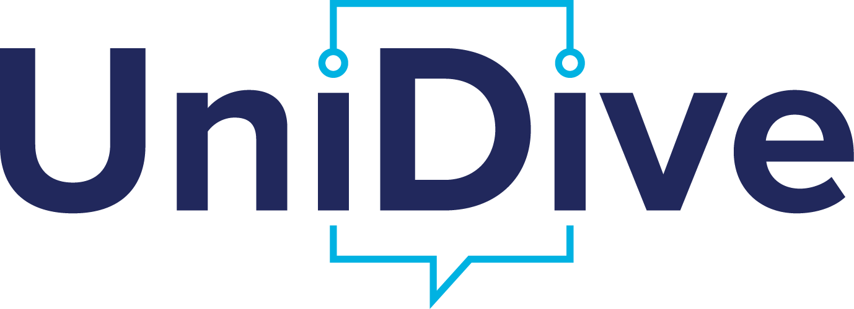 logo has been chosen. More details can be found here.
- [26 May 2023]: A call for local organizers of UniDive 2024 events (the 2nd general meeting and the 1st training school) has been published. Proposal submission deadline: 15 June 2023.
- [26 May 2023]: A call for UniDive logo design competition is being published. The submission deadline: July 7, 2023.
- [25 May 2023]: The first UniDive webinar for newcomers to UD, PARSEME and/or Grew-match will take place on 19 June 2023 (online). The registration deadline is 12 June 2023.
- [17 April 2023]: The 1st call for ITC conference grant applications has been published (deadlines: 25 April and 1 June 2023]
- [open call for joint publications]: All UniDive members are kindly requested to notify the Core Group about all published publications which directly benefited from UniDive. They will be published as outcomes of the Action.
- [3 April 2023]: The monthly online meetings of the Working Group 2 (lexicon-corpus interface) will be taking place every first Thursday of the month from 13:00 CEST (for an hour)
- [2 April 2023]: An UniDive survey for communication purposes has been published. It is dedicated to all UniDive members. Please, fill it in until the 9th of April 2023.
- [11 march 2023]: A heavy strike in public service is planned for Wednesday 15 March. See some recommendations here.
- [7 March 2023]: The registration form for the first UniDive general meeting at Paris-Saclay is open to participants. Please, fill it in asap and no later than Thursday 9 March, in order to help us meet your needs and preferences.
- [17 February 2023]: The list of abstracts selected for the first UniDive general meeting has been published.
- [17 January 2023]: An on-site meeting of Working Group 3 will be taking place on Friday, the 8th of September 2023 in Istanbul.
- [12 December 2023]: The first UniDive general meeting is to take place on 16-17 March 2023 at the Paris-Saclay University in France. A call for abstracts and a form for expression of interest have been published.
- [9 December 2022]: The first call for STSM proposals has been published. The application deadline is 16th January 2023 the 6th of February 2023.
 | Given the fact that we are a multilingual project, we have prepared a video for Valentine's Day. Hope you’ll like it.video_2023-02-14_19-13-17.mp4

