UniDive news
- [5 July 2024]: Our 2nd progress report is due on 22 October. By this time, we should make all the outcomes of the Action visible on the website. Please, send us information about publications, language resources, dissemination activities and other outcomes which directly benefited from UniDive.
- [5 July 2024]: We now have as many as 19 ongoing tasks and subtasks within the 4 Working Groups. They are all documented on the website. If you are interested in joining one of them, please, contact the task leaders.
- [5 July 2024]: The 3rd UniDive General Meeting will take place in Budapest on 29-30 January 2025 and will be preceded by a WG2 meeting on 28 Jan 2024.
- [5 July 2024]: Due to the extended budget and savings from previous events, we are planning a last-minute call for STSMs late July. You may start planning your STSM already now. They should end no later than early October. For all details see the STSM page.
- [5 July 2024]: The 1st UniDive training school is taking place on 8-12 July in Chișinău, Moldova. 3 courses on corpus annotation are offered. We are expecting about 60 trainees from over 20 countries, working on more than 30 languages, most of which low-resourced. We plan to record the courses and make them available after the event.
- [5 July 2024]: The MWE-UD workshop took place on the 25th of May and was co-located with the LREC/COLING conference in Turin. It was the 3rd biggest satellite event of this conference, and UniDive funded 23 participants. The event featured 2 invited talks and 26 archival submissions, which are available at the ACL anthology.
- [5 July 2024]: In April, we received a proposal from COST to extend our budget for year 2. To be able to benefit from it, we drafted the Work and Budget amendment, which was validated by COST and by the UniDive Management Committee. This top-up budget allowed us to substantially increase the funding for the MWE-UD workshop Turin, the training school in Chișinău and the conference grants.
- [20 Feb 2024]: A call for local organizers of UniDive 2025 events (the 3rd general meeting and a WG2 meeting) has been published. Proposal submission deadline: 8 March 2024.
- [19 Feb 2024]: The Joint Workshop on Multiword Expressions and Universal Dependencies (MWE-UD) is taking place May 25, 2024. It is co-located with the LREC-COLING conference. UniDive is one of the co-organizers and sponsors of the event. We dedicated part of the UniDive budget for the workshop participants, mostly invited speakers and paper presenters. The submission deadline is 25 February 2024.
- [19 Feb 2024]: The 2nd General Meeting of UniDive took place on 7-9 February 2024 at the University of Naples L’Orientale, Italy. It gathered around 90 participants. All material from the event is available online.
- [18 Jan 2024]: The instructions for poster presenters in Naples have been published. The submission deadline for posters and booster slides is 29 January.
- [22 Dec 2023]: The list of 40 abstracts selected for the 2nd UniDive workshop in Naples has been published.
- [30 Nov 2023]: An expression of interest form for the 2nd General Meeting in Naples has been published.
- [7 Nov 2023]: A call for reviewers for the UniDive workshop in Naples has been published. To volunteer, fill in this form no later than 19 November 2023.
- [26 Oct 2023]: The second UniDive general meeting is to take place on 7-9 February 2024 at the University of Naples L’Orientale in Italy. A call for abstracts has been published. The submission deadline is 24 November 2023.
- [11 Sep 2023]: The 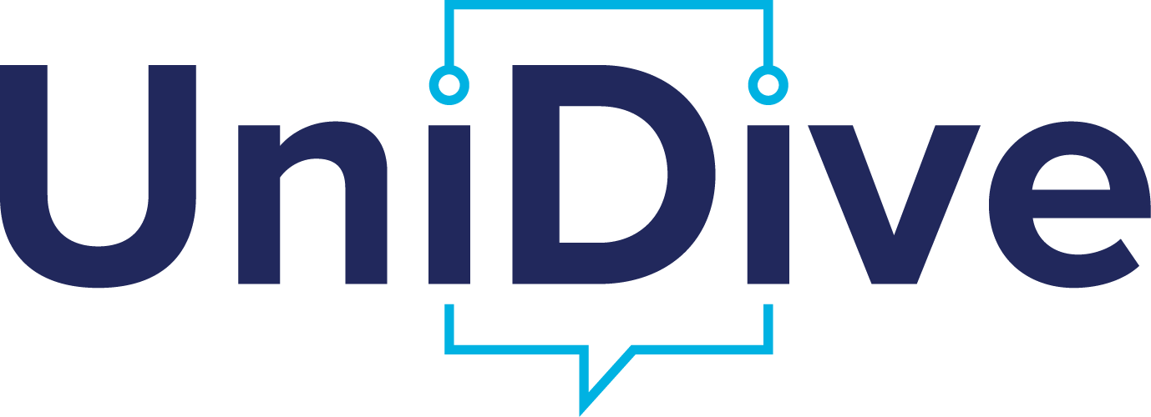 logo has been chosen. More details can be found here.
- [26 May 2023]: A call for local organizers of UniDive 2024 events (the 2nd general meeting and the 1st training school) has been published. Proposal submission deadline: 15 June 2023.
- [26 May 2023]: A call for UniDive logo design competition is being published. The submission deadline: July 7, 2023.
- [25 May 2023]: The first UniDive webinar for newcomers to UD, PARSEME and/or Grew-match will take place on 19 June 2023 (online). The registration deadline is 12 June 2023.
- [17 April 2023]: The 1st call for ITC conference grant applications has been published (deadlines: 25 April and 1 June 2023]
- [open call for joint publications]: All UniDive members are kindly requested to notify the Core Group about all published publications which directly benefited from UniDive. They will be published as outcomes of the Action.
- [3 April 2023]: The monthly online meetings of the Working Group 2 (lexicon-corpus interface) will be taking place every first Thursday of the month from 13:00 CEST (for an hour)
- [2 April 2023]: An UniDive survey for communication purposes has been published. It is dedicated to all UniDive members. Please, fill it in until the 9th of April 2023.
- [11 march 2023]: A heavy strike in public service is planned for Wednesday 15 March. See some recommendations here.
- [7 March 2023]: The registration form for the first UniDive general meeting at Paris-Saclay is open to participants. Please, fill it in asap and no later than Thursday 9 March, in order to help us meet your needs and preferences.
- [17 February 2023]: The list of abstracts selected for the first UniDive general meeting has been published.
- [17 January 2023]: An on-site meeting of Working Group 3 will be taking place on Friday, the 8th of September 2023 in Istanbul.
- [12 December 2023]: The first UniDive general meeting is to take place on 16-17 March 2023 at the Paris-Saclay University in France. A call for abstracts and a form for expression of interest have been published.
- [9 December 2022]: The first call for STSM proposals has been published. The application deadline is 16th January 2023 the 6th of February 2023.
 | Given the fact that we are a multilingual project, we have prepared a video for Valentine's Day. Hope you’ll like it.video_2023-02-14_19-13-17.mp4

