UniDive COST Action CA21167


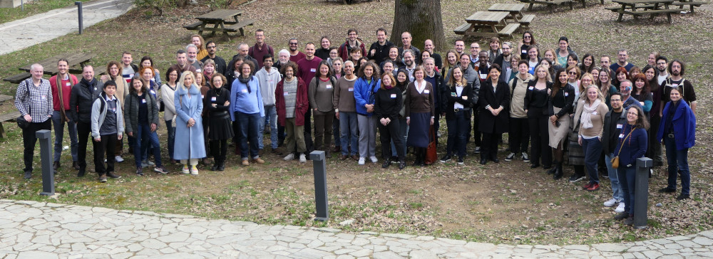

Latest news
- [16 Dec 2024]: A call for local organizers of UniDive 2026 events (the 4th general meeting and 2nd training school) has been published. Proposal submission deadline: 7 February 2025.
- [16 Dec 2024]: The UniDive mailing lists hosted at the Paris-Saclay University have been restored.
- [5 Nov 2024]: The UniDive 2nd Progress Report was submitted to e-cost today.
- [28 Oct 2024]: The 3rd UniDive general meeting, co-located with a WG2 meeting, is to take place on 28-30 January 2024 in Budapest. If you are interested in attending, please, fill in the expression of interest form, best before 11 November.
- [12 Sept 2024]: The deadline for abstracts to submit to the 3rd UniDive workshop in Budapest has been extended till the 30th of September 2024. The submission link is now published, see the event's page.
- [26 August 2024]: Paris-Saclay University, which hosts several services for UniDive, was a victim of a major cyber attack on 11 August 2024. Since then, the UniDive mailing lists are not operational. The services are being progressively restored but we do not yet know how long it will take. In the meantime, if you need to contact the UniDive leaders, see the official COST page.
- [5 July 2024]: We now have as many as 19 ongoing tasks and subtasks within the 4 Working Groups. They are all documented on the website. If you are interested in joining one of them, please, contact the task leaders.
- [5 July 2024]: The 3rd UniDive General Meeting will take place in Budapest on 29-30 January 2025 and will be preceded by a WG2 meeting on 28 Jan 2024.

About UniDive
The CA21167 COST Action, UniDive, is an interdisciplinary scientific network devoted to universality, diversity and idiosyncrasy in language technology.
- It main objective is to reconcile language diversity with rapid progress in language technology.
- It embraces both inter- and intra-language diversity, i.e. a diversity understood both in terms of the differences among the existing languages and of the variety of linguistic phenomena exhibited within a language.
- It gathers about 395 interdisciplinary experts (linguists, computational linguists, computer scientists, psycholinguists, and industrials) from almost 40 COST countries (36 of which are COST countries).
- It represents dozens of languages from many different language genera.

Basic data
- Duration: from 23 September 2022 to 22 September 2026
- Official COST webpage: https://www.cost.eu/actions/CA21167/
- Detailed objectives and workprogram - to be found in the Memorandum of Understanding
- 4 Working Groups
- We welcome new members

Social Media UniDive Profiles
- LinkedIn: UniDive
- Instagram: unidive__ca21167
- Youtube Channel: @UniDiveCA21167
- Facebook: Action COST UniDive
- Twitter: UniDive_CA21167
- TikTok: UniDive_CA21167

