Top Attractions in Chișinău

About Chișinău
The city of Chisinau is situated on seven hills arranged in the shape of a circle. Modern Chisinau was conceived by its designers as a garden city—a settlement where green spaces alternate with buildings, complementing and enhancing them. In such a city, people were meant to feel closer to nature, enjoying everything this notion implies: cool shade during the summer heat, fresh air, soothing greenery, and the morning songs of birds. For decades, green spaces have generously provided this comfort to city residents, becoming Chisinau's hallmark.

Museums
The gre

Parks & Gardens
The green area of the municipality of Chisinau consists of 10 forest parks, 6 parks, 4 public gardens, and 31 squares. In total, they cover approximately 3500 hectares. Bellow are presented just few of them.

"Ştefan cel Mare" Public Garden
The oldest green space not only in Chisinau but also in all of Moldova is the “Ştefan cel Mare” Public Garden, considered a monument of landscape architecture that has retained its charm to this day. The garden was established in 1818 on an area of 7 hectares. Located in the Stefan cel Mare și Sfânt Park in the center of Chisinau, the Alley of the Classics is among the main tourist attractions of the Moldovan capital. The sculptures line the alley on both sides, depicting important figures of Romanian literature from both Romania and the Republic of Moldova. The complex was built in 1958, initially featuring only 12 sculptures.Today, the Alley of the Classics includes 30 busts placed on red granite stones
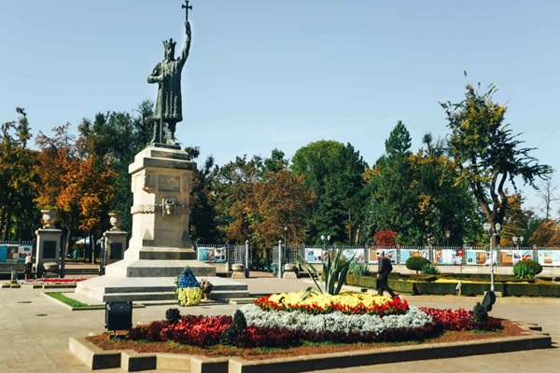
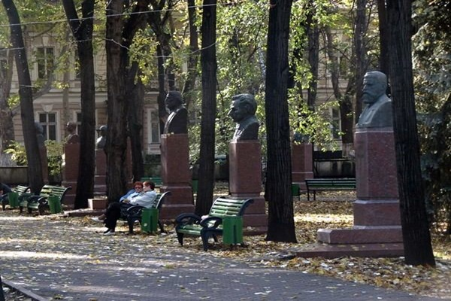
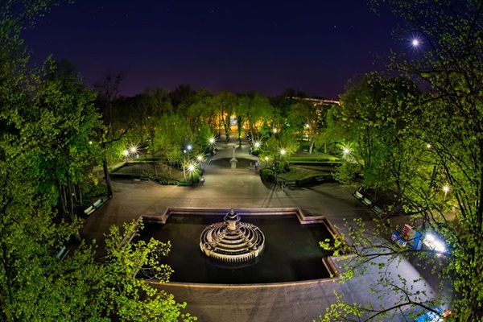
Location: Boulevard Ștefan cel Mare și Sfînt

The Cathedral Park
In the city center lies Cathedral Park. It was founded in 1836 on an area of 9 hectares. Eight straight alleys lead from as many entrances to the park towards the Metropolitan Cathedral of Christ's Nativity, the Bell Tower, and the Holy Water Fountain, forming an expressive ensemble. This year, the park, like the Cathedral, celebrates its 172th anniversary. The Metropolitan Cathedral of Christ's Nativity, located in Cathedral Park, doesn’t look all that impressive from the outside. Built in the 1830s in the neoclassical style it has a turbulent history – the cathedral was destroyed during World War 2 and when Moldova was part of the USSR and religious services were prohibited the building was used as the exhibition center. Today the cathedral stands proudly in the heart of the capital, being in the center of all important events. Be sure to step inside – the interior is stunning, everything you could expect from the Orthodox church in Eastern Europe.
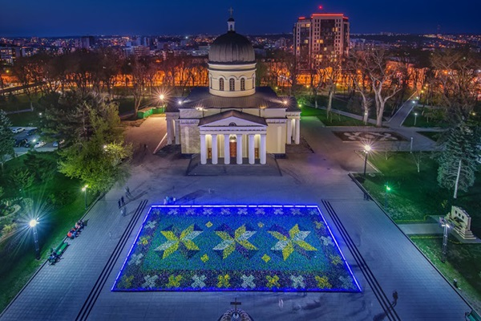
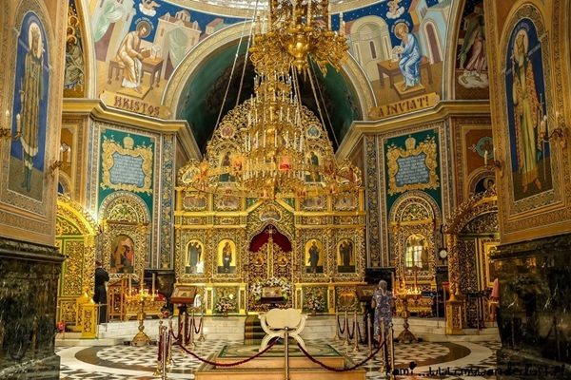
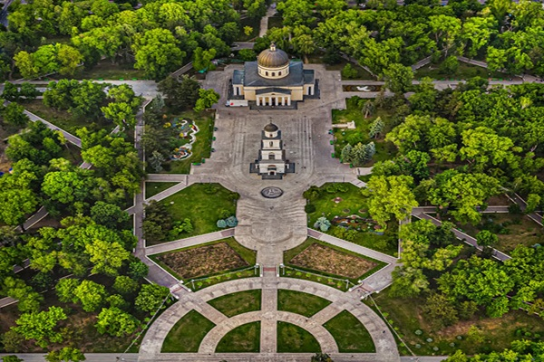
Location: Boulevard Ștefan cel Mare, 2 Catedrala

The Dendrarium Park
The Dendrarium Park in Chisinau is an 83-hectare green oasis in the Buiucani sector. It serves as an important oxygen reservoir for all city residents and is a natural air filter. It is one of the most popular photography spots for city dwellers. The Dendrarium was placed under state protection on July 16, 1998. The park is a member of the International Association of Botanical Gardens for Environmental Conservation. The Dendrarium has an important seed bank of rare and highly decorative plants. This gene pool is represented by 1,820 taxa. It is significant that the park hosts 9 species of woody plants out of the 13 listed in the Red Book of the Republic of Moldova.
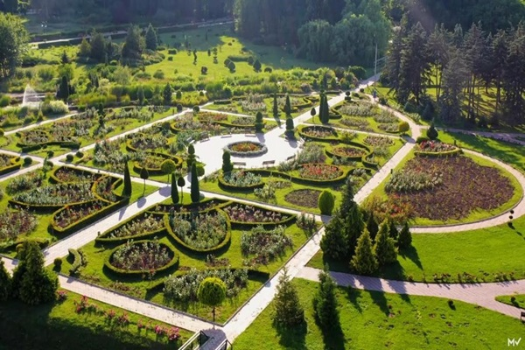
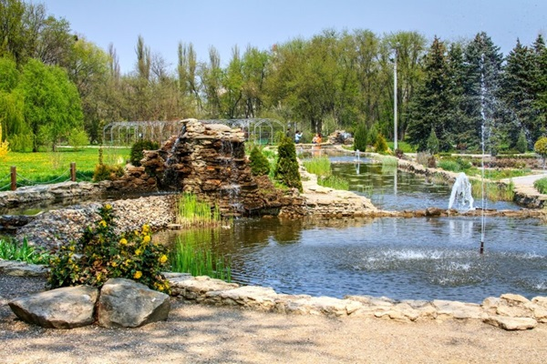
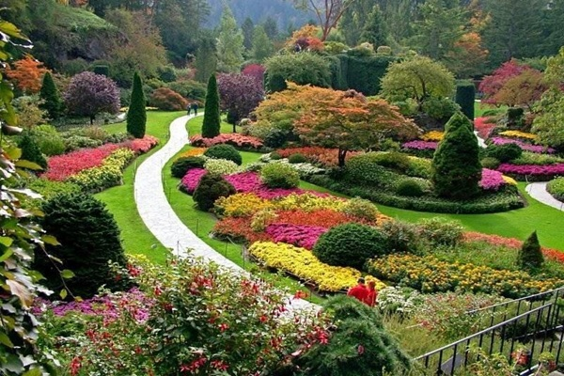
Location: Street Ion Creangă 1, Dendrarium

The Mills Valley Park
Valea Morilor Park is located in the Buiucani sector of the capital. It was established in 1950 at the initiative of L. Brezhnev (First Secretary of the MSSR) and was initially named the “Central Park of Culture and Recreation of the Leninist Komsomol”. The park is situated on the shore of Valea Morilor Lake and covers an area of 114 hectares, with the lake itself occupying 34 hectares. The park's design was developed under the guidance of the renowned architect Robert Kurz.
Within the park, there is an open-air summer theater, the Green Theater, with a capacity of 5,000 seats, a daytime cinema, the children's town “Andrieș,” a beach, a boat station, and more. Over time, the park and its lake have served as a venue for various water sports. The park hosted three rowing schools. Sports fields and fishing spots for amateurs were also set up. In winter, a city skating rink was organized on the frozen lake. There was also a tower for parachute jumps.
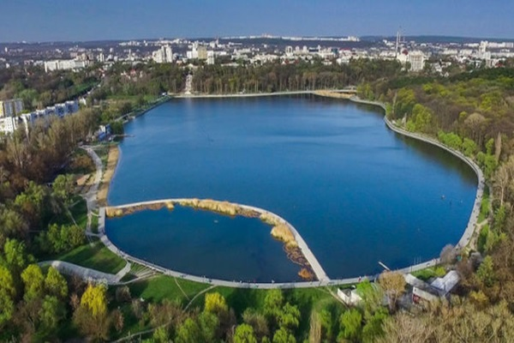
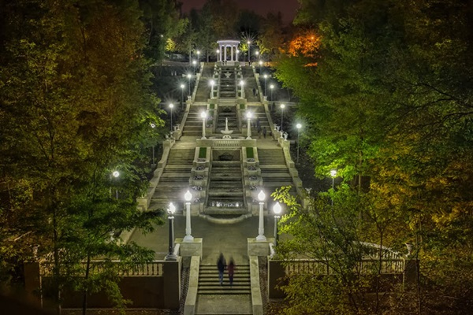
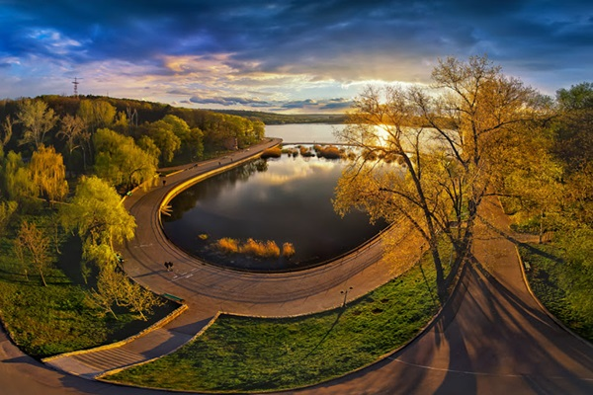
Location: Str. Grigore Alexandrescu, Valea Morilor

The Rose Valley Park
Valea Trandafirilor (Rose Valley). is a renowned park located in the Botanica sector. It spans an area of 145 hectares, of which 9 hectares belong to the lake. The park was established in 1968 on the site of a hill that locals had cultivated for many years with roses, from whose petals they made the famous Chisinau rose jam. This tradition continues to this day, with many special and fragrant species of roses planted in the park every year. This is how the park got its name – Valea Trandafirilor. The Chisinau Zip Line in Valea Trandafirilor Park is the first professional zip line in the Republic of Moldova. It is designed and constructed according to all necessary standards. Located in Valea Trandafirilor Park, it spans approximately 220 meters. The fact that it passes over one of the park's lakes adds an extra dose of adrenaline! The program is daily: 11:00-21:00. Price:5-6 Euro.
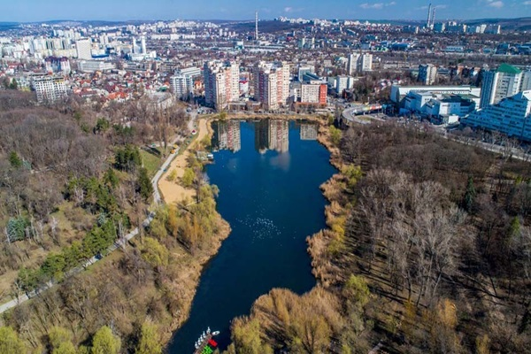
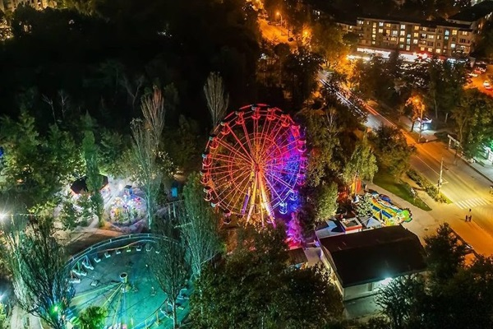
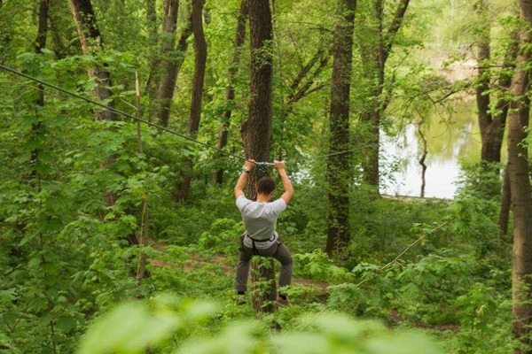
Location: Str. Valea Trandafirilor

The Botanical Garden
The Botanical Garden in Chisinau of the Academy of Sciences of Moldova is the main research structure for botany in the Republic of Moldova. It is located on the outskirts of Chisinau, in the Botanica sector, near the so-called Gates of the City. It was established on September 1, 1951. The design and construction work of the Botanical Garden was carried out under the leadership of Academician A. Ciubotaru, who served as the director of this institution for more than 32 years. The construction of the Botanical Garden was based on the ecological-systematic principle, with the placement of plant groups in a landscape style, facilitating field orientation in the study of vegetation.
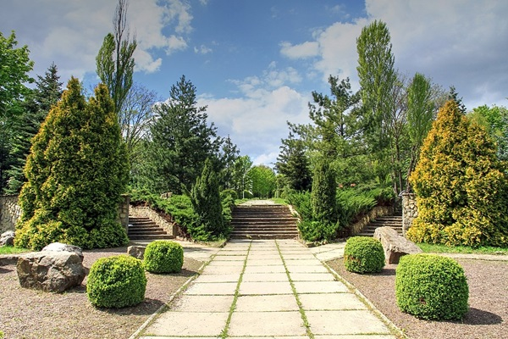
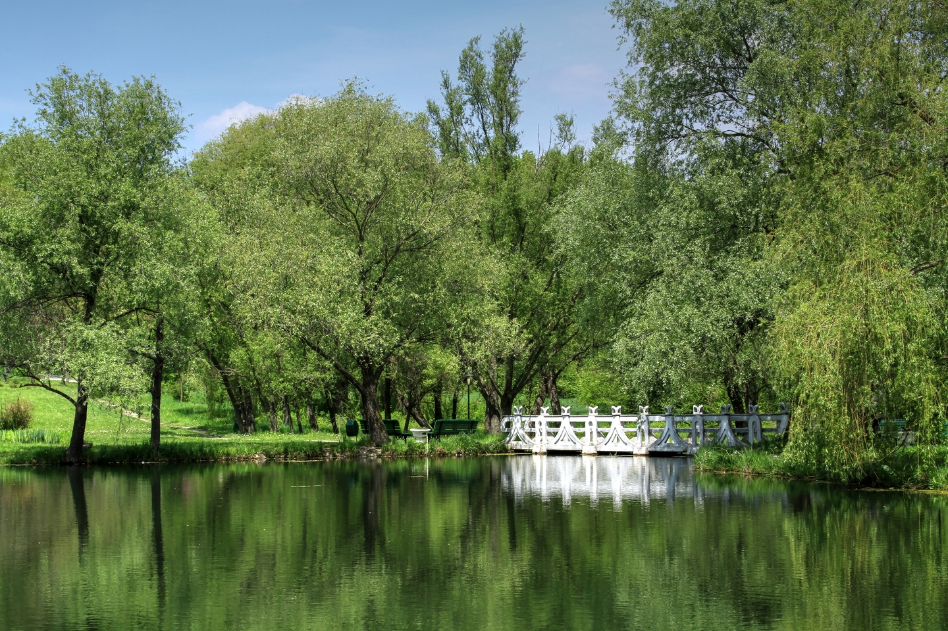
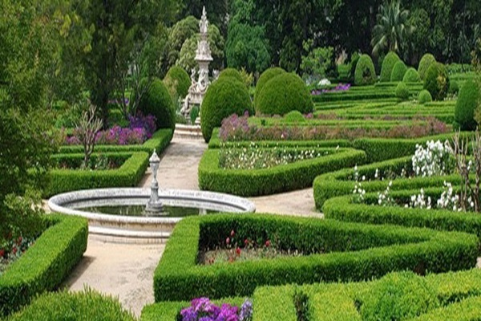
Location: Str. Pădurii 18, Gradina Botanica

Technical University of Moldova Park
The dendrological park of the Technical University of Moldova (UTM) was conceived in 2004 at the initiative of Mr. Ion Bostan, who served as the rector of UTM from 1992 to 2015, as an open-air technical museum. Here, you can admire an impressive gallery of exhibits displayed outdoors: the UTM Stele - the symbol of technical education, the Thinker sculpture - a symbol of the creative thinking of human society, and pieces symbolizing the first inventions of humanity, such as lighting a fire with a spark, up to the most modern and ingenious innovations.
Most of these were created or reconstructed by the students and professors of the University. Helicopters and trams from the last century can also be found here. One of the trams is quite unusual - pulled by two iron horses, bringing to mind the famous horse-drawn tram that ran on Chisinau's main street Alexandru cel Bun (now Ștefan cel Mare și Sfânt Boulevard) in the 1930s-1940s.
In the middle of the park stands the unique fountain with steel sculptures of the 12 zodiac signs. Even some benches installed here are unique creations. They embody two intertwined universal symbols, the heart and infinity, and are nicknamed “The Lovers' Benches.”
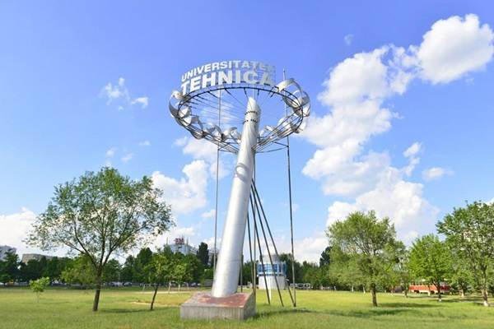
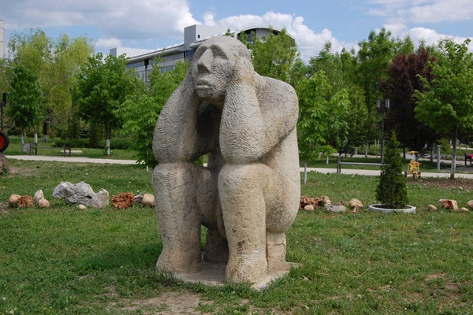
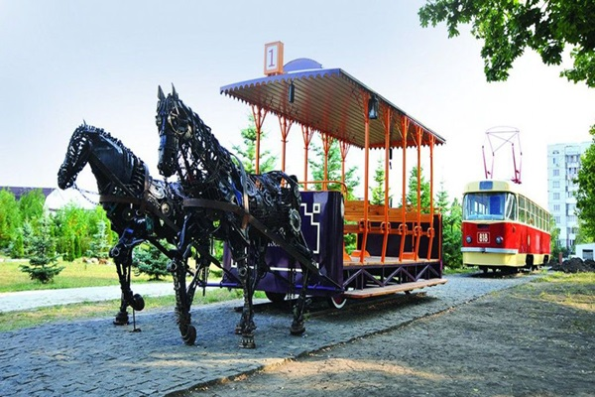
Location: Str. Studenților 9, Universitatea Tehnica din Chisinau

