UniDive Management Committee
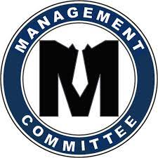
The Action Management Committee (MC) members is a group of researchers, nominated by the COST National Coordinator, in charge of the coordination, implementation, and management of the Action's activities as well as supervising the appropriate allocation and use of the COST funding with a view to achieve the Action's scientific and technological objectives.
The list of the UniDive MC members is maintained on the COST official website.

