1st MC meeting: Brussels, 23 September 2022
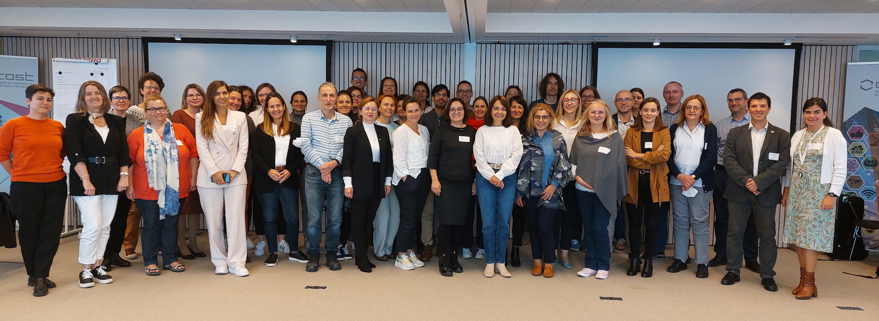
- Event title: 1st Management Committee meeting (MC1)
- Location: Brussels, Belgium, COST office
- Date: 23-09-2022
- Documents:
  - agenda
  - Slides
  - Minutes

