UniDive COST Action CA21167


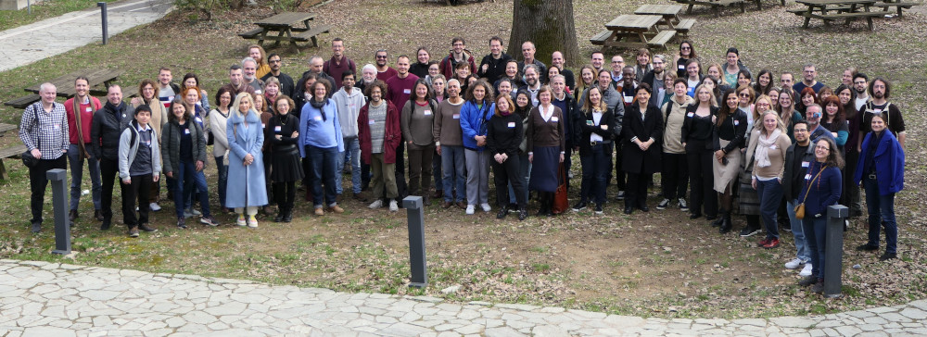

Latest news
- [30 Nov 2023]: An expression of interest form for the 2nd General Meeting in Naples has been published.
- [7 Nov 2023]: A call for reviewers for the UniDive workshop in Naples has been published. To volunteer, fill in this form no later than 19 November 2023.
- [26 Oct 2023]: The second UniDive general meeting is to take place on 7-9 February 2024 at the University of Naples L’Orientale in Italy. A call for abstracts has been published. The submission deadline is 24 November 2023.
- [11 Sep 2023]: The 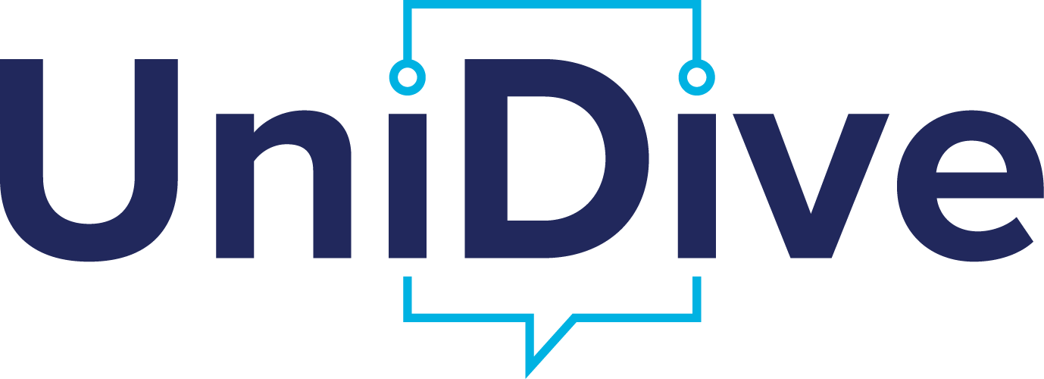 logo has been chosen. More details can be found here.

About UniDive
The CA21167 COST Action, UniDive, is an interdisciplinary scientific network devoted to universality, diversity and idiosyncrasy in language technology.
- It main objective is to reconcile language diversity with rapid progress in language technology.
- It embraces both inter- and intra-language diversity, i.e. a diversity understood both in terms of the differences among the existing languages and of the variety of linguistic phenomena exhibited within a language.
- It gathers about 250 interdisciplinary experts (linguists, computational linguists, computer scientists, psycholinguists, and industrials) from almost 40 COST countries (36 of which are COST countries).
- It represents dozens of languages from many different language genera.

Basic data
- Duration: from 23 September 2022 to 22 September 2026
- Official COST webpage: https://www.cost.eu/actions/CA21167/
- Detailed objectives and workprogram - to be found in the Memorandum of Understanding
- 4 Working Groups
- We welcome new members

Social Media UniDive Profiles
- LinkedIn: UniDive
- Instagram: unidive__ca21167
- Youtube Channel: @UniDiveCA21167
- Facebook: Action COST UniDive
- Twitter: UniDive_CA21167
- TikTok: UniDive_CA21167

